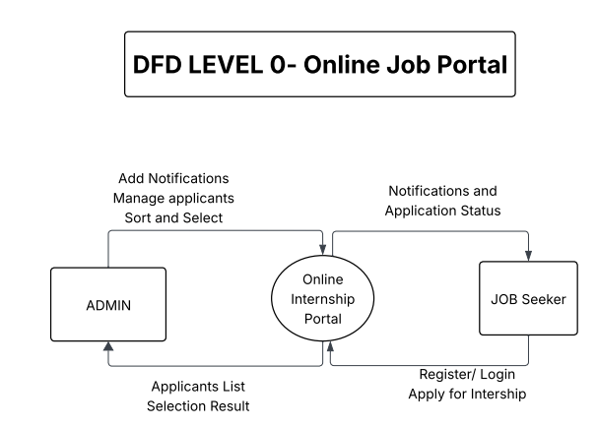

DFD Level-0 Explanation

Overview
The Level-0 Data Flow Diagram (Context Diagram) represents the entire Online Internship Portal as a single process. It shows how the system interacts with external entities without showing internal details.

External Entities

Admin
The Admin interacts with the system to:
Register and log in
Add internship notifications
View applicant lists
Sort applicants by CGPA
Select final candidates

Jobseeker
The Jobseeker interacts with the system to:
Register and log in
View internship notifications
Apply for internships
Check application status

Main Process

Online Internship Portal
This process:
Receives input from Admin and Jobseeker
Processes internship notifications and applications
Produces outputs such as notifications, applicant lists, and selection status

Data Flow Description
Admin sends internship data and selection commands to the system
Jobseeker sends registration, login, and application data
The system sends notifications and selection status back to Jobseekers

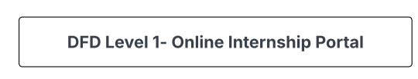

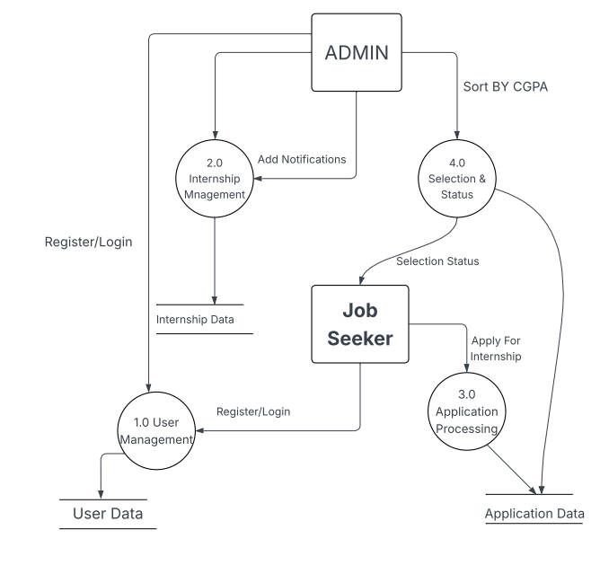

DFD Level-1 Explanation

Overview
The Level-1 Data Flow Diagram breaks the system into major functional processes and shows how data moves between processes, data stores, and external entities.

External Entities

Admin
Manages internship notifications
Views and sorts applications
Selects candidates

Jobseeker
Registers and logs in
Views internships
Applies and checks status

Data Stores

User Data
Stores:
Admin credentials
Jobseeker credentials

Internship Data
Stores:
Department
Internship title
Description
Seats
Result display date

Application Data
Stores:
Applicant name
CGPA
Department
Application status

Processes Explanation

1.0 User Management
This process handles:
Admin registration and login
Jobseeker registration and login
User credentials are verified and stored in User Data.

2.0 Internship Management
This process allows the Admin to:
Add internship notifications
Update internship information
All details are saved in Internship Data.

3.0 Application Processing
This process enables Jobseekers to:
View available internship notifications
Apply for internships
Applications are validated and stored in Application Data.

4.0 Selection and Status
This process allows the Admin to:
View applicants
Sort applicants by CGPA
Select final candidates
It also allows Jobseekers to:
Check their application status
Selection results are updated in Application Data.

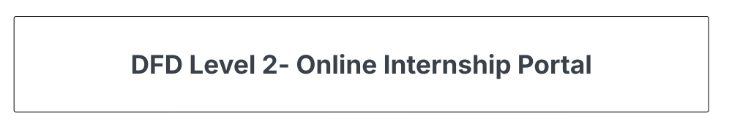

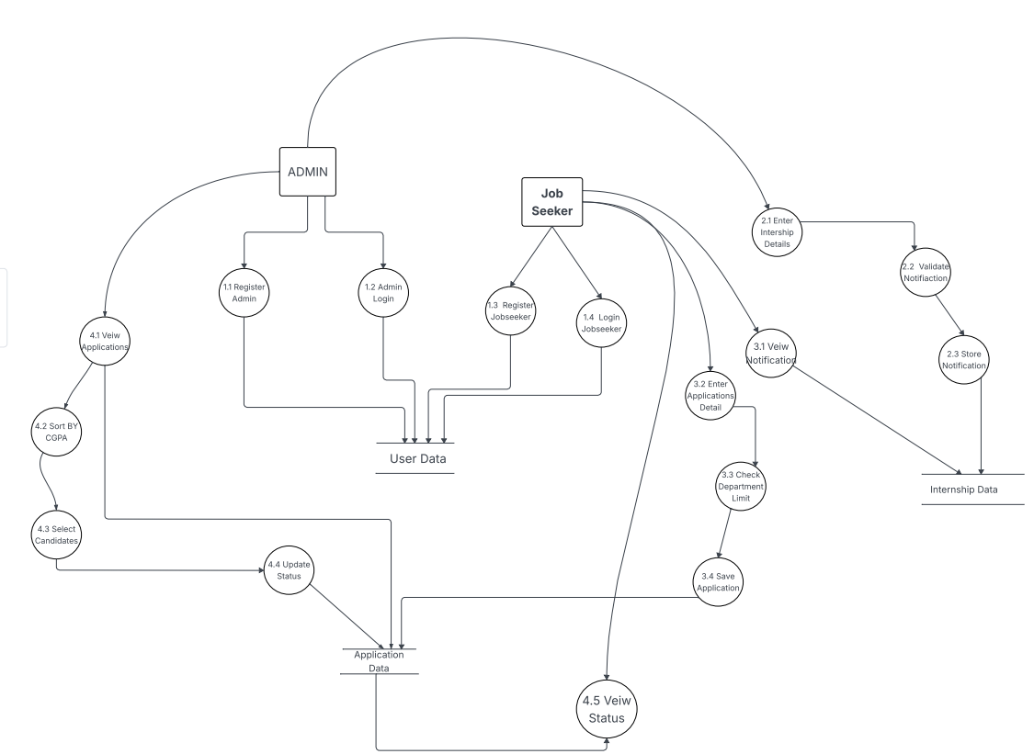

DFD Level 2 Explanation

External Entities

Admin
The Admin is responsible for:
Registering and logging into the system
Adding internship notifications
Viewing applications
Sorting applicants by CGPA
Selecting final candidates

Jobseeker
The Jobseeker:
Registers and logs in
Views internship notifications
Applies for internships
Checks application status

Data Stores

User Data
Stores:
Admin username and password
Jobseeker usernames and passwords

Internship Data
Stores:
Department name
Internship title
Description
Seats
Result display date

Application Data
Stores:
Applicant name
CGPA
Department
Application status (Selected / Not Selected)

Processes Explanation:

1. User Management Processes
1.1 Register Admin
Admin enters username and password.
The system stores admin credentials in User Data.
Only one admin is allowed.
1.2 Admin Login
Admin provides login credentials.
The system verifies them from User Data.
1.3 Register Jobseeker
Jobseeker enters a unique username and password.
The system saves the data in User Data if limit (15) is not exceeded.
1.4 Jobseeker Login
Jobseeker logs in using stored credentials.
The system validates login from User Data.

2. Internship Management Processes
2.1 Enter Internship Details
Admin enters internship information such as department, title, description, seats, and result date.
2.2 Validate Notification
The system checks entered data for correctness and completeness.
2.3 Store Notification
After validation, internship details are saved in Internship Data.

3. Application Processing Processes
3.1 View Notifications
Jobseeker views all available internship notifications retrieved from Internship Data.
3.2 Enter Application Details
Jobseeker enters name, department, and CGPA.
3.3 Check Department Limit
The system checks whether the department already has 5 applicants.
3.4 Save Application
If limit is not exceeded, application details are stored in Application Data.

4. Selection and Status Processes
4.1 View Applications
Admin views all applications department-wise from Application Data.
4.2 Sort by CGPA
The system automatically sorts applicants based on CGPA.
4.3 Select Candidates
Top candidates (according to seats) are selected.
4.4 Update Status
Selected or Not Selected status is updated in Application Data.
4.5 View Status
Jobseeker checks application status retrieved from Application Data.

USECASE DIAGRAM
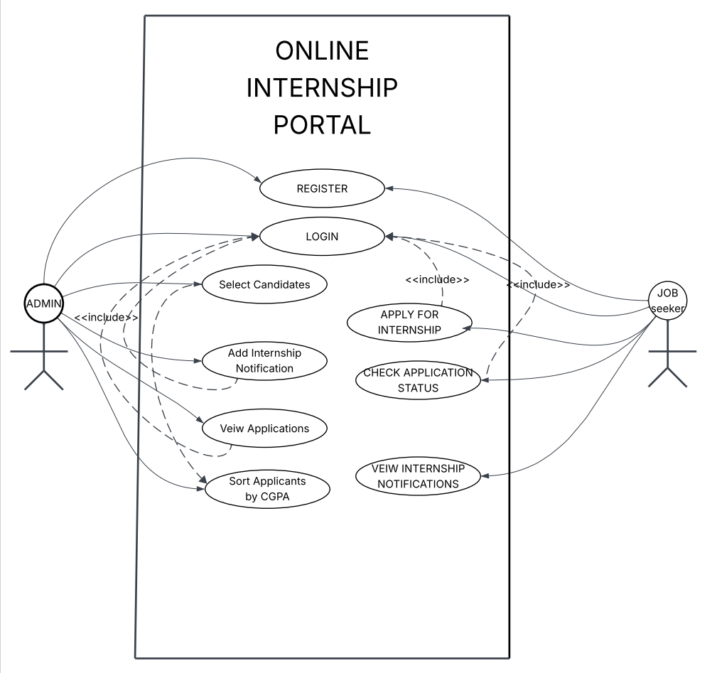

Use Case Diagram

Actors
Admin
Jobseeker

Use Cases :

Register
Allows Admin or Jobseeker to create an account in the system.

Login
Allows Admin or Jobseeker to access the system using username and password.

Add Internship Notification
Allows Admin to add internship details such as department, title, description, seats, and result date.

View Applications
Allows Admin to view all jobseeker applications department-wise.

Sort Applicants by CGPA
Allows Admin to sort applicants automatically based on CGPA.

View Internship Notifications
Allows Jobseeker to see all available internship opportunities.

Apply for Internship
Allows Jobseeker to apply for an internship by providing name, department, and CGPA.

Check Application Status
Allows Jobseeker to check whether they are selected or not.

Sequence Diagram

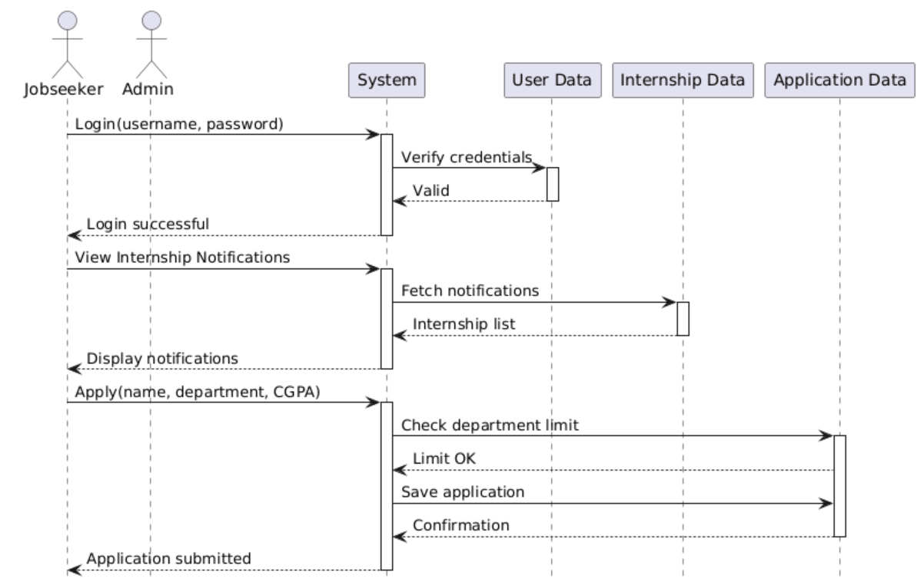
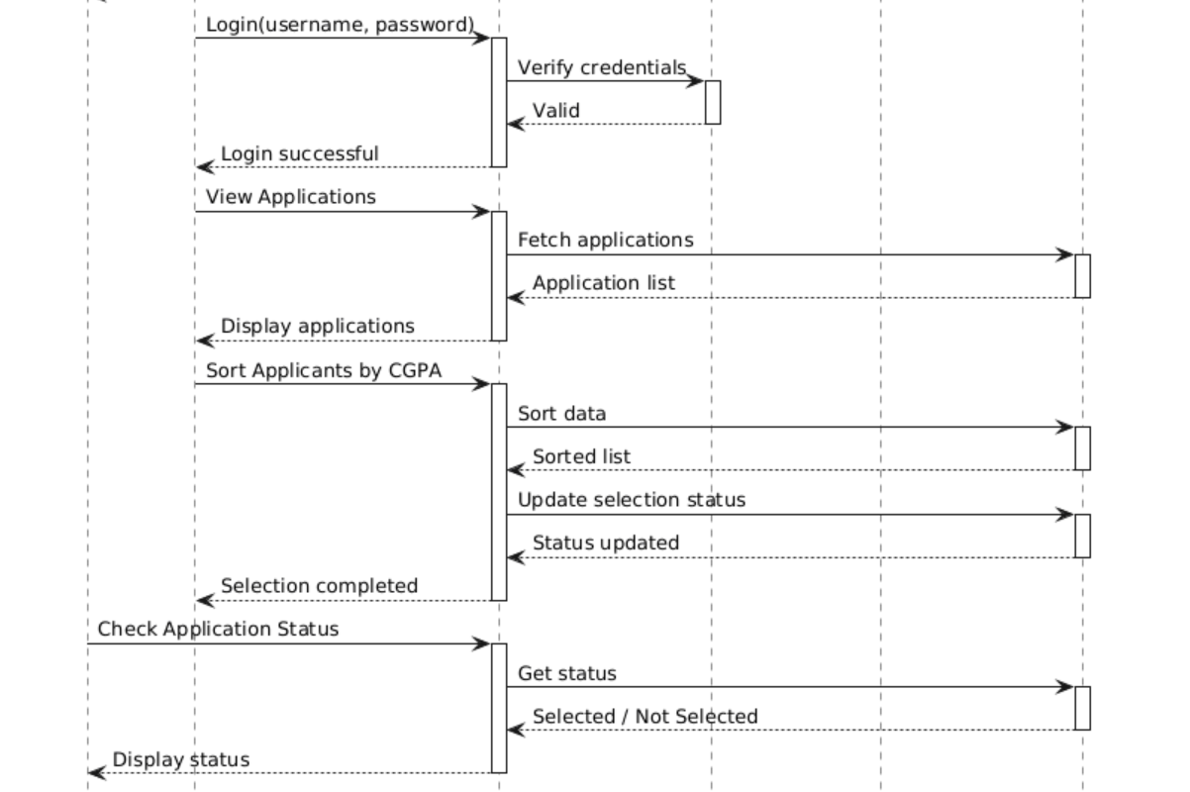

ACTIVITY DIAGRAM

